DYNAMIC REAL TIME WEATHER GENERATION SYSTEM PLUGIN FOR GODOT GAME ENGINE DOCUMENTATION

Ian Kiprono Moses
CIT-227-078/2022

A PROJECT PROPOSAL SUBMITTED TO DR. MUTURI IN PARTIAL FULFILLMENT OF THE REQUIREMENTS OF THE AWARD OF A BACHELORS DEGREE IN SOFWARE ENGINEERING OF THE MULTIMEDIA UNIVERSITY OF KENYA

FEBRUARY 2026

DECLARATION
This project report is my original work and has not been used elsewhere for the award of any academic qualifications in any university
SIGNATURE: 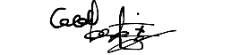 DATE:23/01/2026
NAME: IAN KIPRONO MOSES REG. NO.: CIT-227-078/2022

This project report has been submitted for review with my approval as the University lecturer

SIGNATURE: DATE:
NAME:

FACULTY OF COMPUTING AND INFORMATION TECHNOLOGY
MULTIMEDIA UNIVERSITY OF KENYA

DEDICATION
I dedicate this project to my family and friends for their continuous support and encouragement. Their belief in me has inspired my pursuit in knowledge and creativity. I also dedicate this project to the entire Godot family who will benefit from the use of this project.

ACKNOWLEDGEMENT
I would like to express my dearest gratitude to my supervisor, Dr Muturi for his invaluable guidance and patience during the course of this project development
I also acknowledge the effort, discipline and perseverance needed to complete this project successfully
Above all I thank the Almighty for guiding us though this journey.

ABSTRACT
Weather systems in games is an art that plays a vital role in realism, immersion and enhancing player experience. However, this art is becoming forgotten especially in indie games specifically those made via the Godot game engine. This is because the said games either implement static weather systems due to their simplicity as compared to its dynamic counterpart or omit it entirely due to its complexity in implementation and performance issues if it’s not optimized well. This project presents the design and implementation of a real-time dynamic weather systems to be deployed as a reusable free plugin for the Godot game engine.
The plugin will integrate multiple systems like a dynamic day-night cycle, procedurally generated weather states like fog, rain, storms, snow and clear skies, volumetric cloud generation and rendering and adaptive weather based sound effects. A state-driven approach will be used to manage the weather and its transitions in a real time manner to ensure performance efficiency. Optimizations techniques such as LODs control will be used.
The resulting system will show environmental realism while being customizable to developers and lightweight. This project will show that a performance-aware, modular weather system can significantly enhance immersion for indie and even AA games. Recommendations include incorporation of the different seasons and porting the plugin to other game engines like unity.

TABLE OF CONTENT

LIST OF ABBREVIATIONS
LODS- Level Of Detail
UI – User Interface
NPC – Non-Playable Character
UE5 – Unreal Engine 5
3D – Three Dimensional
Indie = small scale
FPS- Frames Per Second
CPU- Central Processing Unit
GPU – Graphical Processing Unit
DSR- Design Science Research
GLSL – Open GL Shading Language
FR – Functional Requirement
NFR – Non-Functional Requirement

LIST OF FIGURES

LIST OF TABLES

CHAPTER 1: INTRODUCTION

  - Background of the Study
Environmental simulation specifically weather effects play a pivotal yet underrated role in player immersion and realism in the modern 3D video games. These games, like Read Dead Redemption 2 or The Last of Us 2, rely on different dynamic systems like day-night cycles, ambient adaptive sound effects, changing weather states and realistic volumetric cloud rendering to achieve the said environmental immersion and visual aesthetics that the common player base will find appealing.
Despite their importance, weather systems are often simplified into a static weather system, whereby only one weather condition is displayed throughout the game cycle, or entirely omitted in indie games. This is especially evident in games made via the open-source Godot engine since the indie developers often face performance, complexity, time and monetary constraints when they try to implement the advanced dynamic weather systems.
Godot does provide a flexible friendly development environment but it lacks inbuilt solutions for dynamic weather generation as opposed to unity or unreal engine. Thus, the developers using Godot are at a massive disadvantage and they either implement the static weather system, omit the weather system or change their game’s scope and idea. This project looks to address this gap by creating a real time dynamic weather generation system as a reusable plugin for the Godot Engine.

  - Problem Statement
Though weather is a crucial element in game immersiveness, many indie games specially the ones made using Godot game Engine often opt out in its inclusion due to its complexity or time of implementation. Godot’s existing solutions are also plugins but some are geared towards 2D games only and there is only one plugin that is for 3D games but it is performance heavy and complex to use and the visual aspect of it is not realistic. Thus, there is a need for an optimized, customizable, real-time weather system plugin that can be integrated into any Godot based 3D indie games. Such system should include the day and night cycle, multiple weather states, adaptive sound effects, volumetric cloud generation and environmental changes due to weather; like the ground being wet after it rains, without hampering the overall performance of the game.

  - Aim of the Study
The aim of the study is to design and implement a rea-time dynamic weather generation system for 3D Godot games as a reusable plugin for the Godot Engine to enhance immersion and environmental realism in indie 3D games made from Godot
    - Research Objectives
The objectives are to:
- Design a real-time weather system tailored to the integration with the Godot Engine
- Implement a dynamic day-night cycle that will be synchronized with environmental lighting
- Implement multiple weather states including; clear, cloudy, foggy, rainy, stormy and snowy conditions as well as integrating their sound effects to enhance immersion
- Optimize the final plugin to ensure it does not hamper the performance of any project or game it will be used on
  - Significance/ Justification of the study
This study is quite significant as it addresses a huge reoccurring gap in indie 3D Godot game development by providing a reusable and optimized dynamic weather system plugin. The proposed plugin reduces the technical barrier that is commonly associated with implementing complex environmental simulation thereby freeing time for the developers to focus of gameplay or UI. Academically, the project contributes to the research in real-time simulation systems and procedural generation. It offers a customizable solution that can be adapted to any game that was or will be made via the Godot engine
  - Scope of the study
The scope of this project is confined to the development of a real-time weather generation plugin specifically for the Godot game engine. The plugin focuses on environmental simulation; day and night cycles, weather states and their transitions, volumetric cloud generation and rendering and weather based sound effects. Gameplay mechanics, UI, game art and artificial intelligence for NPCs are outside of the scope.
  - Assumptions
The following assumptions are made in this study:
- The target users are indie game developers who make 3D games via Godot engine
- The plugin will be used on hardware that is capable of running modern 3D games
- The developers have some basic understanding of gaming concepts and kwon the layout and functionality of Godot
- Realism is balanced with optimization

  - Limitations
One of the main limitations while working on this project was the performance cost associated with volumetric cloud generation using OpenGL. To mitigate this, optimization techniques like level-of-detail control were used
Also, the system does not account for real world meteorological data such as meteor showers or shooting stars as the weather effects are procedurally generated rather than data driven.

CHAPTER 2: LITERATURE REVIEW
2.1 Introduction
The demand of attention to detail and realism in games has led to more research and implementation of simulation systems like weather systems, day and night cycles and atmospheric effects like clouds which are considered key components in modern 3D games. Thus, many game engines have different approaches to real time weather simulation and procedural environment generation with engines like unity and unreal being at the forefront while Godot is still developing comparable solutions.
This chapter examines the existing literature and related systems to my proposed real-time dynamic weather generation plugin. It examines the popular established weather generation tools/plugins that are used in popular game engines, identifies their strengths, their limitations and shows the gaps that affect indie game development particular in the Godot engine ecosystem. This chapter provides a foundation for the proposed solution by showing the need for an optimized, customizable and easy to use weather system plugin for Godot.
2.2 Related Systems
2.2.1 Weather System 1.0 by matias.lavik Godot plugin
This plugin is specific to Godot and provides weather states with weighted probabilities, particle systems like rain and snow and sky settings. (ref)
2.2.2 Weather Maker – Volumetric clouds and Weather systems for Unity
This plugin provides AAA weather, sky and atmosphere with supposed little effort but it is only confined to users of the Unity game engine. It has features like weather water generation, terrain overlay, volumetric cloud generation and day/night cycles (ref)
2.2.3 Skyscape – Ultra-realistic weather and dynamic sky for UE5
This plugin provides a real-time weather system and dynamic sky lighting for the UE5 specifically. It features seasons, lunar phases, volumetric cloud support and Niagara hooks (ref)

2.3 Limitations and weaknesses of existing systems
While the plugins provide needed leeway when it comes to integrating weather systems into 3D games, each one has their own limitations which are depicted in the table below:
Plugin | Limitations
Weather System 1.0 by matias.lavik Godot plugin | - Has a steep learning curve; it’s not straightforward to use  - It’s not optimized for low end machines thus game dev running Godot on compatibility mode may struggle with the plugin  - Installing it is not, even in a new project, 5 essential files are not installed due to conflicts with Godot program files  - The weather effects, e.g. rain and snow are lack visual realism
Weather Maker – Volumetric clouds and Weather systems for Unity | - It is design for middle and high-end machines; thus, developers who have low end machines can’t use it  - It is expensive to buy  - It only runs solely on Unity thus Godot developers will have to seek alternatives
Skyscape – Ultra-realistic weather and dynamic sky for UE5 | - Designed specifically for high end machines in mind  - Not optimized for low end machines  - It is not free to use, one must buy it  - It is only specific to UE5 and can’t be used on other game engines

These limitations facilitate the need for creating an optimized, customizable and simple to use Godot weather generation system plugin.

2.4 Addressing the Identified Weaknesses
The proposed real-time weather generation Godot plugin aims to address these issues by:
- Ensuring it can run on all machines; High-end to Low-end by using optimization techniques like LODs
- Making it to be free to download and use so that all Godot developers can use it with no upfront or hidden charges
- Ensuring the weather states and particle effects of rain and snow are realistic but at the same time performance friendly
- Making it straightforward to use and providing detail documentation on how to use it

CHAPTER 3: METHODOLOGY

3.1 Introduction
This chapter outlines the methodology that will be used in the design and development of the proposed real time dynamic weather system generation plugin for the Godot Engine. It shows the research approach, system development process, data collection methods and tools used to achieve the previously stated objectives. The methodology that was selected ensures that the developed system is designed in a systematic manner, evaluated and validated to address the identified gap in dynamic environmental simulation in Godot based 3D games.
3.2 Methodology
This study uses the Design Science Research (DSR) methodology. DSR is appropriate for technology-oriented research whose aim is to design, develop, and evaluate an artifact or tool intended to solve a specific identified problem. (Ref)
3.2.1 Description of the Methodology
The DSR process for this project follows the following stages:
3.2.1.1 Problem Identification
The problem that was identified is that Godot does not have in built, native tools that help in the creation of a real-time weather generation system. Unlike other game engines like Unity and Unreal which offer such inbuilt tools. Thereby, Godot small scale developers often rely on third party solutions such as plugins to aid them in environmental simulation, of which there is only one 3D dynamic weather plugin in Godot which has its own drawbacks. This limitation may reduce environmental realism in 3D Godot games
3.2.1.2 Definition of Objectives
Based on the identified problem, the objectives of the study include developing a plugin that improves environmental realism in Godot, ensuring its performance efficiency while supporting multiple weather states.
3.2.1.3 Design and Development of the Artifact
The real-time dynamic weather plugin will be designed and implemented within the Godot Engine Ecosystem and it will incorporate:
- A dynamic day-night cycle that will be synchronized with environmental lighting
- Multiple weather states such as clear, fog, rain, snow etc.
- Dynamic environmental changes like surface wetness after it rains
- Ambient adaptive sound integration e.g., thunder sounds and rain drops hitting surfaces.
- Volumetric cloud rendering
- Performance optimization mechanisms like LODs

3.2.1.4 Demonstration
The to be developed plugin will be used in a sample 3D environment to show all its functionalities. This demonstration will validate the correct implementation of weather transitions, environmental effects, light synchronization and background sound adaptation
3.2.1.5 Evaluation
The plugin will be evaluated using quantitative and qualitative methods. Performance metrics like frame rate and CPU utilization will be measured using the Godot Profiler. Also, the usability and integration complexity will be assessed via the developer feedback.
3.2.1.6 Communication
The evaluation results and systems performance analysis will be documented and presented as part of the final research report
3.3 Justification for using this Design Science Research
The choice of DSR as a methodology method is justified for the following reasons:
- This research study aims to develop a functional software artifact/tool
- The proposal seeks to solve a clearly identified technical gap in the Godot Engine; the lack of a good integrated dynamic weather system plugin
- DSR allows for iterative refinement and evaluation of performance which is essential when making real-time systems that must balance realism and efficiency
Thus, DSR is the perfect methodology to use as it aligns with the project goal of creating, testing and validating a reusable and optimized dynamic weather system plugin.
3.4 Data collection Method and tools
The following data collection methods will be used:

3.4.1 Performance Testing
Quantitative data will be collected, via the Godot profiler, by measuring the before and after integration of the plugin. The following metrics will be recorded:
- FPS
- CPU usage
- Memory consumption
The testing will be done in controlled conditions within a sample 3D scene for consistency.
3.4.3 Developer feedback
Qualitative data will be collected via the structured questionnaires that will be distributed to the Godot forum and Godot subreddits. The feedback will assess:
- Ease of integration
- Usability
- Performance in different machines
- Perceived realism of the weather effects

3.5 Tools and Technologies
The following tools and technologies will be used in the development and evaluation of this plugin@
- Godot Engine- Version 4.6
- GDScript
- C#
- Godot Profiler
- Git
- Visual Studio Code
- GLSL language

CHAPTER 4: SYSTEM ANALYSIS

4.1 Introduction
This chapter goes through an analysis of the current state of weather system implementation in Godot-based 3D games. It examines two realities that current Godot developers face: the manual implementation process whereby developers build the sky and weather from scratch and the use of the only available 3D weather plugin for Godot, Weather System 1.0 by matias.lavik. Both Scenarios will be modelled using diagrams including flowcharts, Context Diagrams, Data Flow Diagrams (DFDs), and UML diagrams to expose their inefficiencies and limitations. This analysis forms the justification for the proposed Dynamic Real-Time Weather Generation System plugin, whose design is addressed in Chapter 5.

4.2 Detailed Analysis of the Current System

4.2.1 Overview of the Current State
Godot game developers who wish to add weather effects to their 3D games currently have two options available to them. The first is manual implementation, where the developer individually assembles weather components using Godot's built-in nodes, scripting and using GLSL. The second is adoption of the existing Weather System 1.0 plugin. Both options present significant challenges that collectively discourage the inclusion of dynamic weather in indie 3D Godot games.
The following subsections analyse each current approach using appropriate system analysis tools.

4.2.2 Context Diagram
The context diagram below maps the boundary of the current weather implementation landscape in Godot using the existing Weather System Plugin 1.0.

4.2.2.1 Context Diagram – Weather System Plugin context
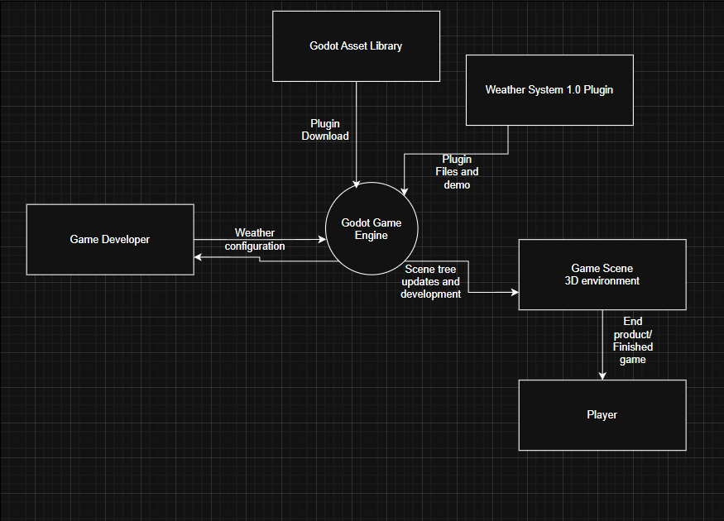
The table below describes all the external entities with their functions in the system above:
External Entity | Role in the current system | Interaction
Game Developer | Primary actor and is responsible for developing the game and using the plugin well for the weather implementation in the game, if needed | Writes C# / GDScript code  Configures Godot nodes and inspector properties
Godot Game Engine | The runtime environment that processes scripts, renders particle systems, manages audio, and applies environment settings. | Receives scene tree updates, particle emitter signals, and audio bus changes from developer scripts.
Weather System Plugin 1.0 | The only available 3D weather plugin for Godot. Provides limited weather states via particle systems and sky settings. | Installed into the Godot project for use by the developer.
Godot Asset library | Online repository where Weather System 1.0 is downloaded from. | Provides the plugin files to the developer's project.
Game scene (3D Environment) | The target environment that receives weather changes. | Receives particle emitter activations, environment node changes, and audio triggers.
Player | The end user who experiences and judges the outcome of the weather implementation during gameplay. | Visually and audibly experiences the result of the current weather setup.

4.2.2.2 Context Diagram – Manual Weather implementation context
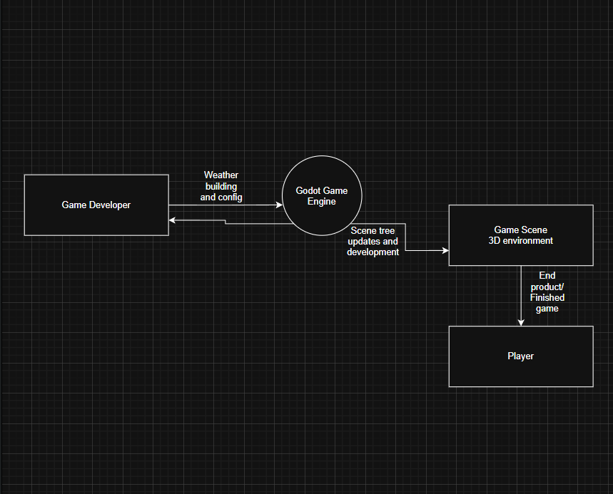
The table below describes all the external entities with their functions in the system above:
External Entity | Role in the current system | Interaction
Game Developer | Primary actor and is responsible for developing the game and manually implementing the weather and its logic from scratch, if needed | Writes C# / GDScript and GLSL code  Configures Godot nodes to run in tandem with the shader language
Godot Game Engine | The runtime environment that processes scripts, renders particle systems, manages audio, and applies environment settings. | Receives scene tree updates, particle emitter signals, and audio bus changes from developer scripts.
Game scene (3D Environment) | The target environment that receives weather changes. | Receives particle emitter activations, environment node changes, and audio triggers.
Player | The end user who experiences and judges the outcome of the weather implementation during gameplay. | Visually and audibly experiences the result of the current weather setup.

4.2.3 Flowchart
4.2.3.1 Flowchart – Manual weather implementation
The flowchart below illustrates the step-by-step process a Godot developer must currently follow when implementing a weather system manually, without any plugin assistance. This represents the most common approach taken by indie developers who are unaware of or dissatisfied with the existing plugin.
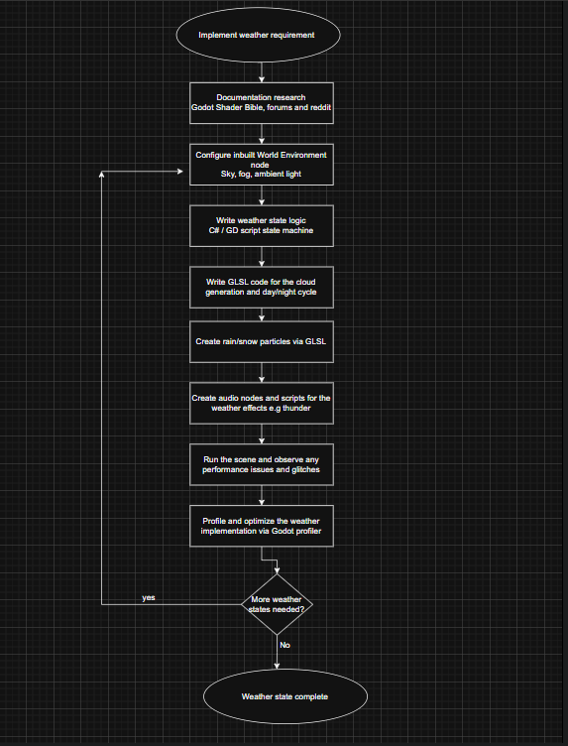
The steps described in the flowchart are as follows:
- Developer identifies and begins to implement the requirement for weather in the game.
- Developer researches Godot documentation and community forums for implementation guidance.
- Developer creates a WorldEnvironment node and manually configures sky, fog, and ambient light properties.
- Developer writes a GDScript or C# class to manage weather state logic and transitions.
- Developer writes GLSL code for cloud generation and day/ night cycle
- Developer creates GPUParticles3D nodes for rain and/or snow and writes particle shader code.
- Developer creates AudioStreamPlayer3D nodes and writes separate scripts to handle ambient audio switching.
- Developer runs the game scene and observes performance issues or visual inconsistencies.
- Developer manually profiles using the Godot Profiler.
- Developer repeats steps 3 to 8 for each additional weather state (fog, storm, snow, etc.).
- If the weather system breaks during game development, the developer must debug all components individually.
As seen above, this process is not only complex but highly inefficient in time constrained projects like game development as each individual weather state can take hours to days to implement and optimize. There is no reusability meaning the process starts from scratch for a new game project.

4.2.3.2 Flowchart – Weather System 1.0 Plugin implementation
The flowchart below models the workflow a developer follows when attempting to use the existing Weather System 1.0 plugin by matias.lavik; the only 3D weather plugin currently available on the Godot Asset Library.
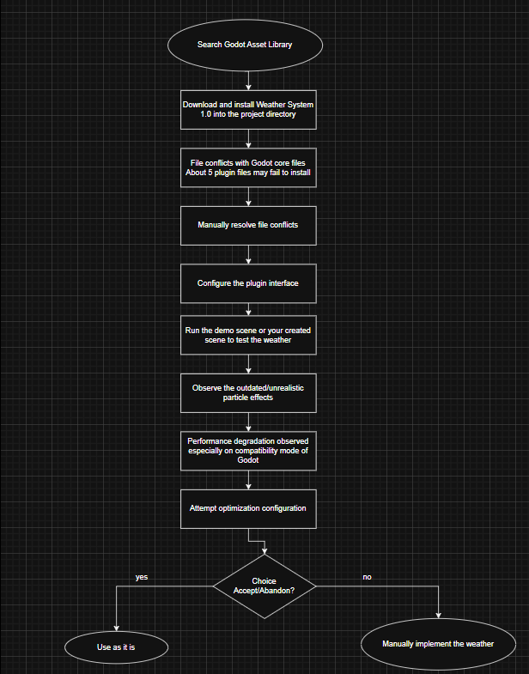
The steps described in the flowchart are as follows:
- Developer searches the Godot Asset Library for a weather plugin.
- Developer downloads and installs Weather System 1.0 into their Godot project.
- Installation encounters file conflicts with core Godot program files; 5 essential plugin files fail to install correctly.
- Developer must manually resolve installation conflicts by relocating or renaming conflicting files.
- Developer attempts to configure the plugin via its interface, which has a steep learning curve and limited documentation.
- Developer runs the game scene to test weather effects.
- Developer observes visually unrealistic rain and snow particle effects.
- Developer observes performance degradation on low-end or mid-range machines, particularly on Godot Compatibility (OpenGL) rendering mode.
- Developer attempts to configure optimization settings but finds the plugin offers limited control over performance tuning.
- Developer decides to either accept the limitations, or abandon it and resort to manual implementation
The above process shows that the existing plugin, while a valid attempt to address the gap, introduces its own set of problems due to its lack of updates that may leave some developers worse of than the manual approach.
4.2.4 Data Flow Diagrams
4.2.4.1 Level 0 – Manual weather implementation
This level 0 DFD below provides a high-level overview of the data flows in the current manual weather implementation in Godot.
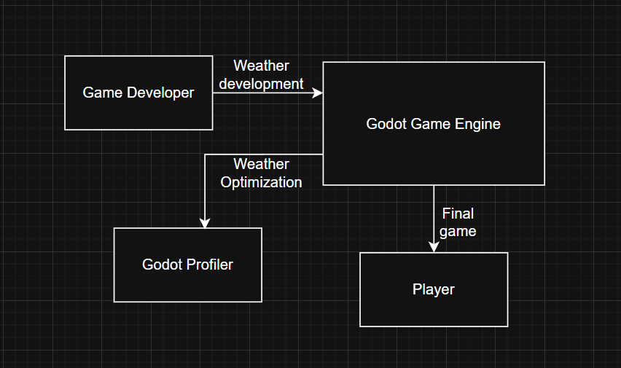

The table below highlights the data flow:
Data Flow | Direction | Description
Weather development | Developer to Godot Engine | GD script/ C# code, node hierarchies, GLSL, inspector settings, test scenes
Rendered Scene | Godot Engine to Godot profiler | Optimization
Final game | Godot Engine to Player | For testing or commercially sold

4.2.4.2 Level 0 – Weather System 1.0 Plugin Implementation
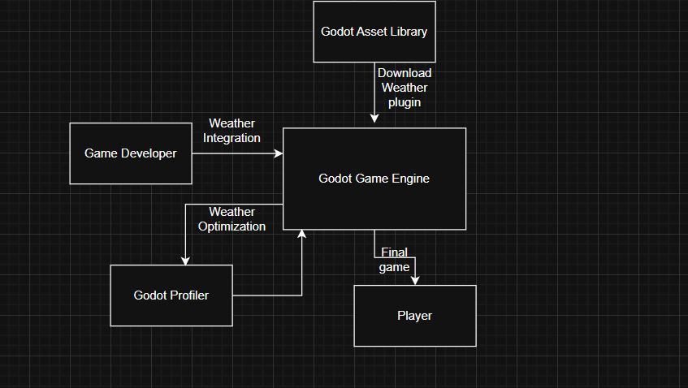

The table below highlights the data flow:
Data Flow | Direction | Description
Weather Integration | Developer to Godot Engine | Download the weather 1.0 plugin for use
Rendered Scene | Godot Engine to Godot profiler | Optimization
Final game | Godot Engine to Player | For testing or commercially sold

4.2.4.3 Level 1 – Manual weather implementation
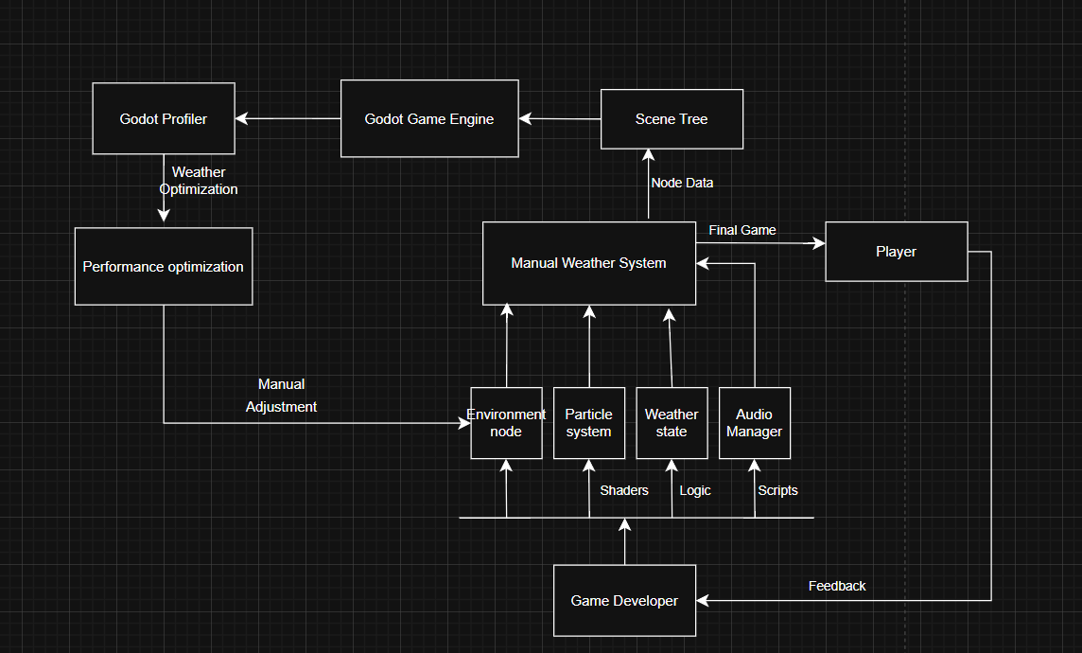

The following table explains the data flows:
Data Flow | From | To | Description
Manual Configuration | Game Developer | Sub processes (1-4) | The developer handles the direct making of the weather by using audio scripts, shaders, logic and code
Node Data | Manual Weather system | Scene tree | All the nodes and scripts and shaders for the weather implementation are combined
Weather Optimization | Godot Profiler | Performance optimization | CPU/CPU Metrics indicating which processes are heavy are read and interpreted
Manual Adjustment | Performance optimization | Environment node | The developer manually optimizes the weather system and running it to see if it works as intendedly optimized
Final Game | Manual Weather System | Player | The player gets a chance to play test the game together with the weather system
Feedback | Player | Developer | The player submits a subjective assessment of the game as well as its components such as the weather system for the developer to follow up

4.2.4.4 Level 1 – Weather System 1.0 Plugin Implementation
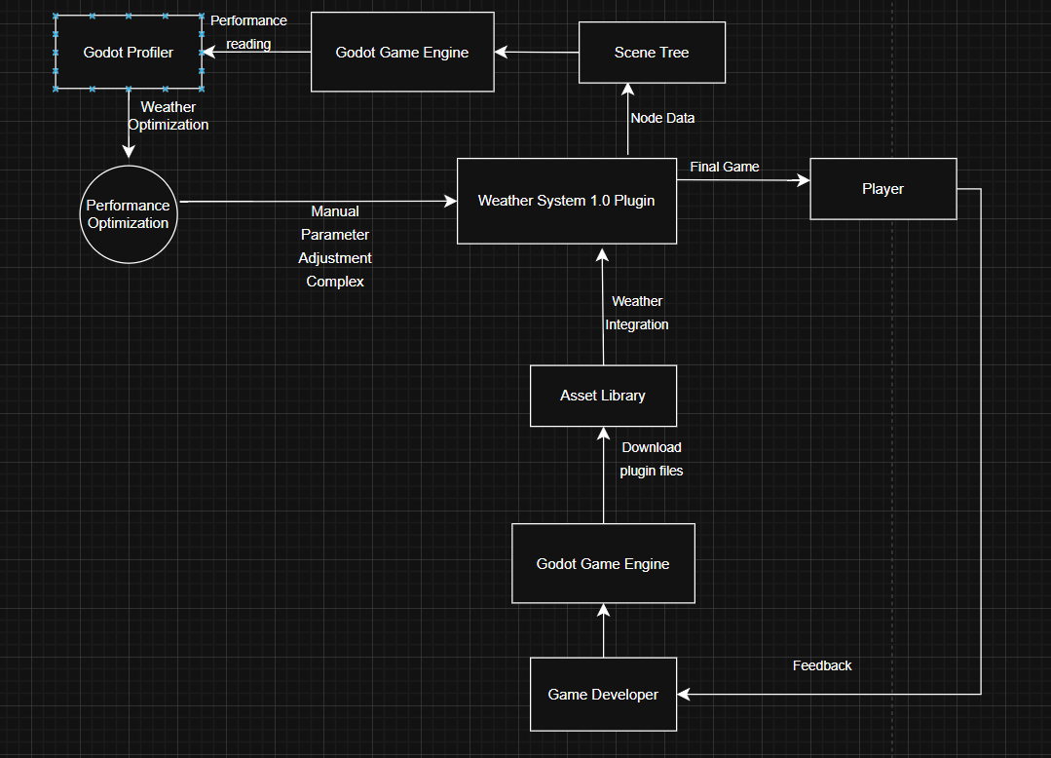

The following table explains the data flows:
Data Flow | From | To | Description
Download Plugin | Asset Library | Weather System 1.0 | The developer downloads the plugin files which include scripts shaders and a demo scene
Weather Integration | Game Developer | Godot Game Engine | The developer installs all the files related to the plugin
Node Data | Weather System 1.0 | Scene Tree | Automated injection of plugin-specific nodes into the project hierarchy.
Performance Reading | Godot Game Engine | Godot Profiler | Real-time data on how the plugin is impacting the engine's renderer.
Complex Adjustment | Performance Optimization | Weather System 1.0 | Attempting to tweak plugin parameters to fix any performance issues.  This is complex since it involves changing the plugin’s raw code and shaders
Final Game | Manual Weather System | Player | The player gets a chance to play test the game together with the weather system
Feedback | Player | Developer | The player submits a subjective assessment of the game as well as its components such as the weather system for the developer to follow up

4.2.5 UML Use Case Diagram
The UML Use Case Diagrams below models the interactions between the primary actors; the Game Developer and the Godot Engine and the use cases they engage with in the current system. Thess diagram reflects what is currently possible, not what the proposed plugin will provide.
4.2.5.1 Manual Weather Implementation
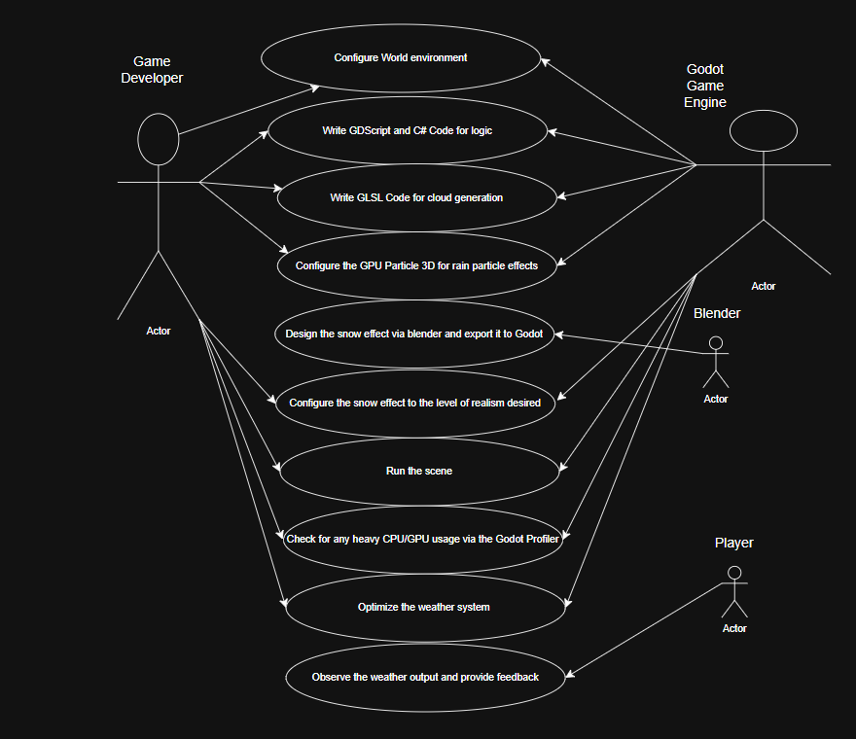

The following table describes the Use Case diagram above:

Use Case | Actor | Description | Limitation
Configure World Environment | Game Developer, Godot Engine | Developer manually adjusts the WorldEnvironment node properties (Sky, Fog, Tonemap). | No native interpolation; changes are static and must be manually updated for time-of-day shifts.
Write Logic Code (GDScript/C#) | Game Developer, Godot Engine | Developer writes custom state machines and transition logic to handle weather changes as well as the day and night cycle | Logic is often project-specific and difficult to port or reuse.
Cloud Generation (GLSL) | Game Developer, Godot Engine | Developer writes custom GLSL shader code for volumetric or billboard cloud rendering. | Extremely high technical barrier; difficult to optimize for different hardware.
Configure Rain Particles | Game Developer, Godot Engine | Developer sets up GPUParticles3D for precipitation effects. | Manual setup for every scene; difficult to achieve "splash" or "wetness" effects automatically.
Design/Export Snow Effect | Game Developer, Blender | Developer creates 3D assets or specialized meshes for snow and exports them to Godot. | Frequent workflow "friction" between Blender and Godot; scaling assets can break particle collision.
Run Scene & Profile | Game Developer, Godot Engine | The scene is executed to check for visual bugs and monitor CPU/GPU performance. | Entirely reactive; issues are only found after the work is complete.
Optimize Weather System | Game Developer | Manual reduction of particle counts or shader complexity based on profiler data. | No automation; optimization often sacrifices visual quality due to lack of LOD systems.
Observe & Feedback | Player | The player experiences the final environment and provides feedback on immersion. | Realism is limited by the developer’s individual skill in multiple technical disciplines.

4.2.5.2 Weather System 1.0 Plugin Implementation

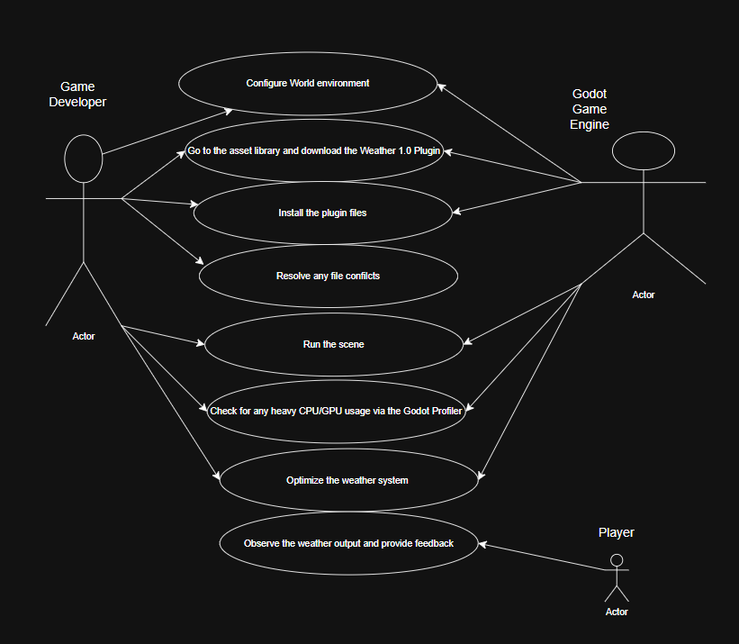
The table below explains in depth the Use Case diagram above
Use Case | Actor | Description | Limitation
Download Plugin 1.0 | Game Developer, Godot Engine | Developer fetches the plugin archive from the Godot Asset Library.
Install Plugin Files | Game Developer, Godot Engine | The process of adding the plugin files to the project directory and enabling them. | There is a high risk of file conflicts
Resolve File Conflicts | Game Developer | Developer manually compares project files to fix naming or directory overlaps caused by the plugin. | Time-consuming; requires the developer to understand the plugin’s internal file structure.
Run Scene | Game Developer, Godot Engine | Running the game to see how the "Black Box" plugin renders the weather. | Hard to debug; if the weather breaks, the developer cannot easily find where in the plugin logic it failed.
Check Profiler | Game Developer, Godot Engine | Monitoring performance impacts specifically caused by the plugin's code/particles. | The plugin often lacks optimization for "Compatibility" (GLES3) rendering modes.
Optimize Weather System | Game Developer | Attempting to tweak the plugin’s hidden parameters or modifying its source code for better FPS. | Modifying plugin source code makes it impossible to update the plugin in the future without losing changes.
Observe & Feedback | Player | The player experiences the weather generated by the third-party tool. | Visuals are "generic" and may not fit the artistic style of the game; no intensity control.

4.2.6 Sequence Diagram
The sequence diagrams below will show the needed steps that a developer must take in the current Godot system in order to integrate a weather system in their small-scale game.
4.2.6.1 Manual Weather Implementation
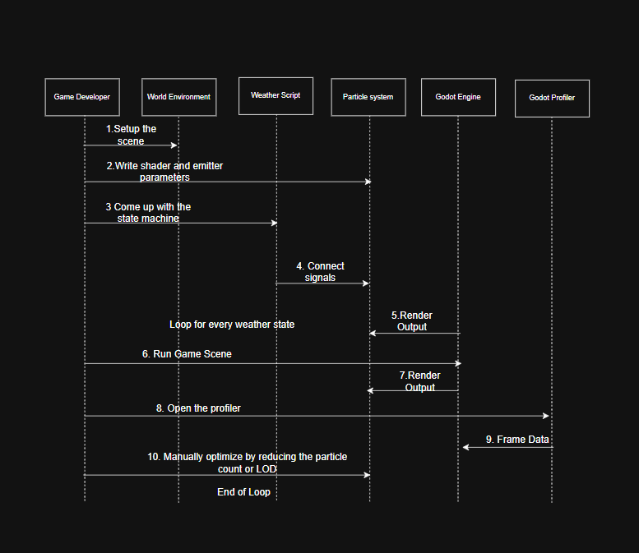

The sequence diagram above outlines the interactions when a developer decides to manually implement the weather in their indie game:
- The developer setup the 3D scene; he/she ensures the World Environment 3D node is present in the scene
- The developer then writes the shader and emitter parameters
- He/she the designs the state machine to handle logic via C# or Gd script
- The necessary signals e.g., WeatherUpdated are connected to the particle system
- The output is then rendered and displayed
- The developer then runs the game scene to see if the weather logic works
- The output is rendered again after running the game
- For optimization purposes, the developer goes to the Godot profiler to see which processes are too heavy
- He/she acquires the data needed to profile the processes frame by frame
- The developer then uses optimization techniques like LODs to optimize the system

4.2.6.2 Weather System 1.0 Plugin Implementation

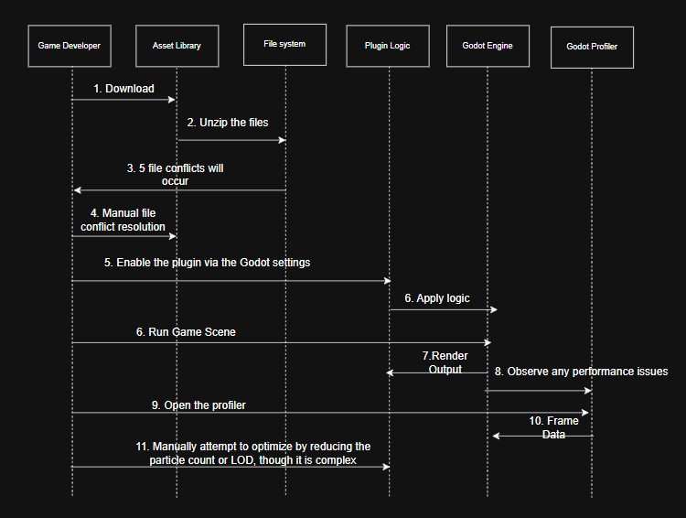
The sequence diagram above outlines the interactions when a developer decides to use the Weather System 1.0 Plugin to incorporate w their indie game:
- The developer downloads the plugin from the asset library
- The plugin is then automatically unzipped showing you its files
- About 5 file conflicts will occur between the plugin and Godot internal files
- The developer will manually resolve this issue
- The developer will then head to Godot settings to activate the said plugin
- She/he will then apply the weather logic via a small menu that comes with the plugin e.g. finetuning the rain intensity
- The developer then runs the game scene to see if the weather logic works
- The output is rendered after running the game
- Any performance bottlenecks are observed by the developer via the Godot profiler
- For optimization purposes, the developer goes to the Godot profiler to see which processes are too heavy
- He/she acquires the data needed to profile the processes frame by frame
- The developer then uses optimization techniques like LODs to optimize the system

4.3 System Requirements
Based on the detailed analysis of the current system above, the following functional and non-functional requirements have been identified for the proposed Dynamic Real-Time Weather Generation System plugin. These requirements are derived from the limitations and gaps observed in the current approaches.

4.3.1 Functional Requirements
Functional requirements define the specific capabilities and behaviours the proposed plugin must provide to address the shortcomings of the current system.
ID | Functional Requirement | Priority | Addresses Gap In
FR-01 | The plugin shall provide a dynamic day-night cycle that automatically updates directional light angle, intensity, and sky colour in real time. | High | Both current approaches lack any day-night cycle support.
FR-02 | The plugin shall support at least six weather states: Clear, Cloudy, Foggy, Rainy, Stormy, and Snowy. | High | Manual approach requires full re-implementation per state; Weather System 1.0 offers limited states.
FR-03 | The plugin shall implement smooth interpolated transitions between all weather states. | High | Neither current approach provides automated smooth transitions.
FR-04 | The plugin shall use GPU particle systems to render precipitation effects (rain and snow) with configurable intensity and realistic visual appearance. | High | Weather System 1.0's particle effects are visually unrealistic.
FR-05 | The plugin shall generate and render volumetric clouds with configurable density and coverage. | High | Not present in any current Godot weather solution.
FR-06 | The plugin shall play adaptive ambient audio (e.g., rainfall, thunder, wind) synchronized with the active weather state. | Medium | In the current manual approach, audio must be separately scripted and is not synchronized automatically.
FR-07 | The plugin shall apply surface effect shaders (ground wetness after rain, snow accumulation after snowfall) driven by the active weather state. | Medium | Not available in any current approach.

4.3.2 Non-Functional Requirements
Non-functional requirements define the quality standards, constraints, and performance targets the proposed plugin must satisfy to be viable for the target audience of indie Godot developers.

ID | Non-Functional Requirement | Category | Acceptance Criterion
NFR-01 | The plugin shall maintain a minimum of 55 FPS on a mid-range machine when all weather features are active in a standard 3D test scene. | Performance | Godot Profiler records >= 55 FPS with all plugin sub-systems active.
NFR-02 | The plugin shall impose no more than 20% additional CPU overhead above a baseline scene without the plugin active. | Performance | Godot Profiler CPU delta between plugin-active and plugin-inactive states is <= 20%.
NFR-03 | The plugin shall implement LOD control for volumetric cloud rendering to reduce GPU load on low-end hardware. | Performance / Scalability | Observable LOD switching reduces GPU draw calls on low-end hardware.
NFR-04 | The plugin shall support both the Forward+ (Vulkan) and Compatibility (OpenGL) rendering backends in Godot 4.x. | Compatibility | Weather effects render correctly on both rendering modes in Godot 4.6.
NFR-05 | The plugin shall be free to download and use with no licensing fees. | Accessibility | Plugin is published on the Godot Asset Library at zero cost.
NFR-06 | The plugin shall install cleanly into a new Godot project with no manual conflict resolution required. | Reliability / Usability | Zero file conflicts reported during a clean installation into a new Godot 4.6 project.

4.4 Algorithims
This section describes the core algorithms that will be used to drive the behaviour of the proposed Dynamic Real-Time Weather Generation System plugin. The system relies on a state-driven approach combined with procedureal generation techniques to simulate realistic weather transitions and environmental changes.#
4.4.1 Weather State Machine Algorithm
The weather state machine is the central controller of the plugin. It manages the current weather state, drives transitions between states, and dispatches update signals to all subsystems (particles, audio, shaders, lighting).
Pseudocode:
STATES = {CLEAR, CLOUDY, FOGGY, RAINY, STORMY, SNOWY}
current_state = CLEAR
transition_duration = 5.0 seconds
FUNCTION request_transition(new_state):
IF new_state == current_state THEN RETURN
target_state = new_state
blend_factor = 0.0
WHILE blend_factor < 1.0:
blend_factor += delta / transition_duration
interpolate_params(current_state, target_state, blend_factor)
emit_signal("weather_updated", blend_factor)
current_state = target_state

The interpolate_params function linearly blends environment parameters (fog density, sky colour, light intensity) between the source and target state profiles. The blend_factor ranges from 0.0 (fully in current state) to 1.0 (fully in target state), ensuring no abrupt visual jump occurs during any weather transition (FR-03).
4.4.2 Day-Night Cycle Algorithm
The day-night cycle algorithm maps an elapsed in-game time value to a sun angle, directional light colour, and ambient intensity. It runs on every frame update and drives the DirectionalLight3D and WorldEnvironment nodes to produce continuous and smooth lighting transitions (FR-01).
Pseudocode:
day_duration = 600.0 // seconds per full in-game day
FUNCTION update_day_cycle(delta):
time_of_day = (time_of_day + delta) MOD day_duration
t = time_of_day / day_duration // normalised [0.0, 1.0]
sun_angle = t * 360.0 // 0=midnight, 90=sunrise, 180=noon
light_intensity = MAX(0, SIN(radians(sun_angle)))
sky_colour = sample_gradient(sky_gradient_curve, t)
directional_light.rotation_degrees.x = sun_angle - 90
directional_light.light_energy = light_intensity
world_environment.background_color = sky_colour
The sky_gradient_curve is a Gradient resource in Godot that maps the normalised time value to an RGBA colour, allowing the developer to define the precise hues of dawn, noon, dusk, and midnight easily without altering the algorithm itself but via use of a linear gradient texture only.
4.4.3 LOD-Based Cloud Rendering Algorithm
The LOD-based cloud rendering algorithm addresses the core performance constraint identified in NFR-03. It evaluates the current hardware rendering mode and real-time frame rate, then selects an appropriate cloud rendering tier, ensuring the plugin remains usable on both high-end (Forward+/Vulkan) and low-end (Compatibility/OpenGL) machines.
Pseudocode:
FUNCTION select_cloud_lod(current_fps, render_mode):
IF render_mode == COMPATIBILITY OR current_fps < 40:
// LOD 2: billboard sprite clouds; cheapest draw cost
activate_billboard_clouds(density, coverage)
ELSE IF current_fps < 55:
// LOD 1: simplified GLSL raymarch; reduced step count
activate_raymarched_clouds(step_count=16)
ELSE:
// LOD 0: full volumetric GLSL raymarch; highest quality
activate_raymarched_clouds(step_count=64)
LOD 0 uses a 64-step GLSL raymarching shader to produce full volumetric clouds. LOD 1 reduces the step count to 16, preserving depth cues while significantly cutting GPU cost. LOD 2 replaces the shader entirely with pre-rendered billboard sprites, making the plugin viable even on Godot's Compatibility (OpenGL) rendering mode where complex fragment shaders are most constrained.
4.4.4 Adaptive Audio Synchronization Algorithm
The adaptive audio synchronisation algorithm listens to the weather_updated signal from the state machine and cross-fades ambient audio tracks to match the active weather state, eliminating the hard audio cuts that plague the manual approach (FR-06).

Pseudocode:
audio_map = { CLEAR: "wind_light.ogg", RAINY: "rain_loop.ogg",
STORMY: "storm_thunder.ogg", SNOWY: "blizzard.ogg", ... }
ON SIGNAL weather_updated(new_state, blend_factor):
outgoing_player.volume_db = lerp(0, -80, blend_factor)
incoming_player.stream = audio_map[new_state]
incoming_player.volume_db = lerp(-80, 0, blend_factor)
IF blend_factor == 1.0:
outgoing_player.stop()
SWAP outgoing_player AND incoming_player

4.5 Dataset
This project does not rely on pre-collected or third party datasets, instead, it uses procedurally generated data at runtime. The sections below describe each category of data used.
4.5.1 Weather Parameter Profiles
Each of the six weather states (Clear, Cloudy, Foggy, Rainy, Stormy, Snowy) is defined by a hand-authored parameter profile stored as a Godot Resource (.tres) file. Each profile contains the target values that the state machine interpolates towards during a transition and the initial value of the said weather state.
The key parameters are:
Parameter | Type | Range | Source | Description
fog_density | float | 0.0 -1.0 | Self made | Density of atmospheric fog via WorldEnvironment
precipitation_intensity | float | 0.0 -500.0 | Self made | GPUParticles3D emission amount per second
sky_color_gradient | Gradient(RGBA) | Color Curve | Self made | Sky colour mapped across the 24-hour time axis
light_intensity | float | 0.0 -1.0 | Computed (SIN) | DirectionalLight3D energy derived from sun angle
cloud_coverage | float | 0.0 -1.0 | Self made | Fraction of sky covered by the GLSL cloud shader
ambent_audio_track | ogg | Enum | Self made | Audio file mapped to each weather state

4.5.2 Performance Benchmark Dataset
Quantitative performance data will be collected using the Godot Profiler during the evaluation phase. The dataset records runtime metrics from a standardised 3D test scene under controlled conditions, with and without the plugin active:
Metric | Unit | Tool | Acceptance Criterion
Frames per second | FPS | Godot Profiler | Must be >= 55 FPS on mid-range hardware (NFR-01)
CPU Frame Time | ms | Godot Profiler | Delta between baseline and plugin-active must be <= 20% (NFR-02)
GPU Draw Calls | Count/frame | Godot Profiler | Verify LOD switching reduces draw calls on low-end mode (NFR-03)
Memory Usage | MB | Godot Profiler | Monitor plugin memory footprint across all six weather states
Transition smoothness | FPS variance | Godot Profiler | No frame spikes (>10ms jump) during any weather state change

4.5.2 Audio Dataset
Audio datasets are needed in this plugin which are mapped into different weather states and intensity levels. These datasets are stored as a dictionary in a configuration file.
Weather State | Sound Effect | Intensity Variant
RAINY | rain.ogg | Light, Medium, Heavy
STORMY | thunder.ogg | Distant, Near, Striking
STORMY | wind_howl.ogg | Low, Medium, High
SNOWY | snow_fall.ogg | Single variant
CLEAR | ambient_clear.ogg | Dawn, day, dusk

